201804英语（二）

一 、单选题

1、There are a lot of other great things to do in this ________ city.

A.incredibly B.forward

C.credit D.incredible

参考答案：D

2、

For many people cars usually ________ personal freedom.

A.destory B.symbolize

C.symbol D.go with

参考答案：B

B

3、It is important that students develop an ________ of how the Internet can be used.

A.awareness B.warning

C.attitude D.aware

参考答案：A

4、Your suggestion will ___________ to solving the problem.

A.contribution B.dispute

C.contribute D.devote

参考答案：C

5、The movie bears little ________ to the original novel, especially the plot development.

A.resemble B.resemblance

C.situation D.condition

参考答案：B

6、There is a general __________ that things will soon get better.

A.belief B.believing

C.believed D.believable

参考答案：A

7、We should distinguish _______ right and wrong.

A.between B.from

C.beyond D.through

参考答案：B

8、Twenty-five dollars was ________ more than he had expected to pay.

A.considerable B.remarkable

C.considerably D.marvelous

参考答案：C

9、The museum is full of __________ and precious treasures.

A.rare B.rarely

C.common D.normal

参考答案：A

10、It is _______ to buy cigarettes in Britain if you are under 16.

A.legal B.possible

C.illegal D.permission

参考答案：C

11、He looked distinctly _______ when the subject was mentioned.

A.noisy B.alike

C.uncomfortable D.believable

参考答案：C

12、Direct __________ between the two languages is not possible.

A.comparison B.compare with

C.compare D.comparing

参考答案：A

13、Do you agree with the use of animals in __________ experiments?

A.science B.scientific

C.education D.living

参考答案：B

14、They answered with ____________ that it was against the rules.

A.assurance B.assure

C.certain D.sure

参考答案：A

15、Is there a French word that is the exact ________ of the English word”home”?

A.equivalent B.the same

C.equal D.the equal

参考答案：A

16、These results are _________ with the findings of the previous study.

A.consist B.consistent

C.consistency D.consisted

参考答案：B

17、We were in ________ the same financial position as before.

A.precisely B.precise

C.differently D.definite

参考答案：A

18、This system could deliver services to local communities more _______.

A.efficient B.efficiently

C.effective D.effectively

参考答案：D

19、My parents never ________ to tell me when I look bad.

A.hesitation B.want

C.hesitate D.stop

参考答案：C

20、He glances briefly towards her but there was no sign of __________.

A.recognize B.recognition

C.recognizing D.recognizer

参考答案：B

21、The accused man showed little sign of _______ as he was sentenced.

A.emotion B.through

C.to D.emotional

参考答案：A

22、The campaign to drive the drug _________ away will continue.

A.deal B.dealerships

C.dealers D.consumer

参考答案：C

23、I am going to ________ to the manager about this.

A.complain B.say

C.complaint D.consult

参考答案：A

24、Angela wished she could think of some words of _____ for her friend, but her mind was a complete blank.

A.wise B.using

C.importance D.wisdom

参考答案：D

25、A series ________ accidents disordered the shop.

A.like B.of

C.about D.through

参考答案：B

26、When judging his performance, don’t take his age _______ account.

A.with B.forward

C.into D.ahead

参考答案：C

27、I hope the divorce won't have a ________ effect on the children.

A.positive B.negation

C.negative D.good

参考答案：C

28、The mayor has been meeting with city council members ________.

A.individually B.through

C.out D.individual

参考答案：A

29、I am really looking forward ________ the summer vacation.

A.after B.towards

C.to D.before

参考答案：C

30、The competition is a lot ________ than what it was even a few years back.

A.like B.tougher

C.tough D.through

参考答案：B

二 、填空题

31、

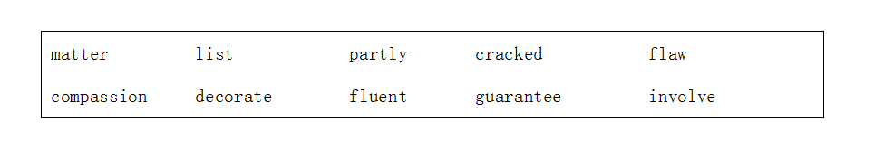

31. As long as you are happy, that’s all that ____________.

32. Tom didn’t read _________ till he was nearly eight.

33． We are making a ________ of the top ten men we would not want to be married to.

34. A famous brand name is not necessarily a _____ of quality.

35. I feel _________ responsible for the problems we’re having.

36. Any investment _______ an element of risk.

37. She passed her tongue over her dry and _________ lips and tried to speak.

38. I was hoping she might show a little _______ for victims of war.

39. There are serious ________ in the way we train our teachers.

40. You can use shells to _______ boxes, trays, mirrors or even pots.

参考答案： 31. matters 32. fluently 33. list 34. guarantee 35. partly 36. involves 37. cracked 38. compassion 39. flaws 40. Decorate

32、

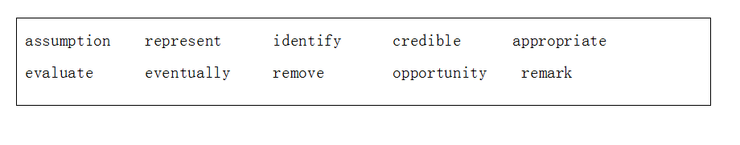

31.The men came to ____________ the rubbish from the backyard.

32.She sees the bar as a starting point and ________ plans to run her own chain of country inns.

33.The job pays well, but there’s not much _________ for career advancement.

34.The judges ________ on the high standard of entries for the competition.

35.In my opinion, there was no ____________ evidence against him.

36.Even the smallest baby can __________ its mother by her voice.

37.People tend to make ___________ about you based on your appearance.

38.This new report ______________ the current situation in our schools.

39.The performance of each employee is ____________ once a year.

40.We need to ensure that the teaching they receive is _________ to their needs.

参考答案： 31. remove 32. eventually 33. opportunity 34. remark 35. credible 36. identify 37. assumption 38. represents 39. evaluated 40. appropriate

33、

Street art is a very popular form of art that is spreading quickly all over the world. You can find it on ___11____, sidewalks, street signs and trash cans(垃圾桶) from Tokyo to Paris, from Moscow to Cape Town. Street art has become a ___12__ culture and even art museums and galleries(画廊) are collecting the works of street _____13_____.Street art started out very secretly because it was ___14____ to paint public and private things without _____15_____ (允许).People often have different opinions about street art. Some think it is a crime and others think it is a very beautiful new form of culture.

Art ____16___say that the street art movement began in New York in the 1960s. Young adults __ _17___ words and other images on walls and trains. This colorful,__18_ _ style of writing became known as graffiti(涂鸦). Graffiti art showed that young people wanted to be against society. They didn’t want to accept rules and travelled around cities to create _____19______that everyone could see. In many_____20_____, they had trouble with the police and the local government.

【 】 11. A. buildings B. house C. apartment D. flat

【 】 12. A. world B. global C. earth D. nations

【 】 13. A. host B. artists C. airhostess D. assistant

【 】 14. A. legal B. forbidden C. illegal D. warn

【 】 15. A. agree B. agree C. negotiate D. permission

【 】 16. A. experts B. professor C. teachers D. lecturer

【 】 17. A. sprayed B. said C. told D. murmured

【 】 18. A. energetic B. energy C. emotion D. power

【 】 19. A. paint B. brush C. pen D. paintings

【 】 20. A. fact B. cases C. occasion D. behavior

参考答案： 11. A 12. B 13. B 14. C 15. D 16. A 17. A 18. A 19. D 20. B

34、

Questions 21 to 30 are based on the following passage

填词补文。下面短文有10处空白，短文后列出10个词，请根据短文内容将其分别放回原来位置，以回复文章原貌。

Language is one of the things that sets us apart as beings, one of the things that essentially __21___ as humans. When language is used well it can elicit very deep feeling in others, motivate others to ___22____ define the nature of our relationships. Sometimes in poetry the juxtaposition（并列）of two words or a certain phrase can bring __23____to the eyes, call up a whole host of imagery and move us deeply. We have seen language recently used in the politics of persuasion, used for __24___or ill - depending on your viewpoint. When we use language to ___25____our true feelings to someone it can open and deepen the connection between us. Language is a very __26______tool. How we use language shapes our world both ___27_______and externally. How you use self-talk - what you say to yourself about yourself and about the world directly ___28____ your experience of both yourself and the world. How you deliver communication shapes the way the world ___29_______ you. We can use language more effectively in both spheres: internal and external and directly influence the health and power of our __30_______relationships and our business relationships.

|  |  |  |  |  |
| --- | --- | --- | --- | --- |
| A. powerful | B. defines | C. action | D. tears | E. express |
| F. shapes | G. internally | H. responds to | I. personal | J. good |

21. _________ 22._________ 23.__________ 24.____________ 25.____________

26. _________ 27._________ 28.__________ 29.____________ 30.____________

参考答案： 21. B 22. C 23. D 24. J 25. E 26. A 27. G 28. F 29. H 30. I

35、

Questions 31 to 35 are based on the following passage

Friendship and Loyalty

When the terrorist attack on September 11th caused people to flee the building, Avremel Zelmanowitz risked his own chance of escape by staying behind with his friend and colleague, Ed Beyea, who was Confined to a wheelchair due to a paralysis (瘫痪). Both men lost their lives, but the stray of Avremel's love and devotion to his friend conveys a life-giving message to all.

Avremel never married, and he shared a house with his brother and his family. He was a loving uncle to his brother's children; and he was devoted to caring for his aging parents. He was a "family man" in every sense of the word. At the same time, he had his own life, his varied interests, and a job and friends.

When the tragedy occurred, Avremel was age 55, and his friend, Ed Beyea, was age 42. Ed became disabled after a diving accident at age 22, but he managed to work 14 years at Blue Cross since his injury. Both he and Avremel were program analysts who worked on the 27th floor of World Trade Center.

Avremel had joined the office two years after Ed was hired, and the two became very close friends. They both loved books and music—often trading books and tapes, and they both served as the special uncle of their respective families. Like Avremel, Ed had no children of his own, but he was a father figure to his two nephews after their father died. Both friends had a great sense of humor, although Ed was strong and outgoing, while Avremel was the more quiet of the pair.

On the morning of September 11, Ed wanted to wait until he could be securely carried down by several rescue workers, as it was dangerous for someone with his disability to be moved. Avremel wouldn't allow his friend to wait alone when everyone else was fleeing the building, and he stayed with him.

In the days that followed, the media learned about Awemel's selfless act, and the story began to spread. President Bush, in his national prayer address to the American people, referred to Avremel's act as one of the many "outstanding acts of sacrifice" that were demonstrated by Americans during this crisis.

31. What happened to Avremel and Ed during the 9,11 terrorist attack?

A. Avremel rescued Ed at the cost of his life.

B. Both Avremel and Ed gave up their chance of escape.

C. Avremel stayed with Ed and both lost their lives.

D. Both Avremel and Ed were finally rescued.

32. Avremel and Ed were similar in that _____________.

A. both of were in their 50s

B. both of them loved books and music

C. both of them were disabled.

D. both lived with their brother's families.

33. Which of the following statements is true according to the passage?

A. Avremel took care of Ed's life after work.

B. Avremel liked diving when he was young.

C. Ed became disabled after a driving accident.

D. Ed was not able to get downstairs himself.

34. Why did Avremel choose to stay when others were fleeing the building?

A. Because he expected the rescuers to help him.

B. Because he tried to carry Ed downstairs.

C. Because he didn't want to leave Ed behind.

D. Because he thought it was safer to stay inside.

35. The word "address'' in the last paragraph means ....

A. speech B. solution C. information D. title

参考答案： 31. C 32. B 33. D 34. C 35. A

36、

assumption challenge unrest credible guilt

victim eventually remove mutual equal

36. The men came to ____________ the rubbish from the backyard.

37. She sees the bar as a starting point and ________ plans to run her own chain of country inns.

38． The company is ready to meet the ________ of the next few years.

39. I hope we can at least agree to disagree in a spirit of ________ respect.

40. In my opinion, there was no ____________ evidence against him.

41. General___________ in the country increased as hunger set in.

42. People tend to make ___________ about you based on your appearance.

43. This achievement is unlikely ever to be ________.

44. We have all been ________ of selfishness at some time in our lives.

45. He is a/an ___________ of an illness over which he has no control.

参考答案：

36. remove 37. eventually 38. challenge 39. mutual 40. assumption

41. unrest 42. credible 43. equal 44. guilty 45. victim

37、

The Language of Confidence

The language we use programs our brains. Mastering our language gives us a great degree of mastery over our lives and our destinies. It is important to use the language in the best way possible in order to dramatically improve our quality of life.

Even the smallest of words can have the deepest effect on our subconscious mind, which is like a child, and it doesn't really understand the difference between what really happens and what you imagine.It is eager to please and willing to carry out any commands that you give it - whether you do this knowingly or not is entirely up to you.

"Try"

It is a small word yet it has an amazing impact upon us. If someone says, "I'll try to do that" you know that they are not going to be putting their whole heart into it, and may not even do it at all.How often do you use the word try when talking about the things that matter to you? Do you say "I'll try to be more confident" or "I'll try to do that" or "I'll try to call"?

Think about something that you would like to achieve, and say it to yourself in two different ways. Firstly say, "I'll try to …" and notice how you feel. Next say, "I will do…" and see how you feel.

The latter makes you feel better than the first one, doesn't it? It gives you a sense of determination, a feeling that it will be done. Listen to the people around you and when they say they will try notice if it gets done or not. Eliminate the word try from your dictionary and see how your life improves.

"Can't"

This is another small word with a big impact. It disempowers us, makes us feel weak and helpless, and damages our self-esteem.It limits our infinite abilities and stifles creativity. Rub it out from your internal dictionary and replace it with something that makes you feel great.

Instead of saying you can't, why not say something like "I choose（愿意）…" or "I choose not to …". Using words like this allows you to take back your power and to be in control of your life.

Words may appear small and insignificant, yet they can have a deep and lasting effect on us.Mastering your language gives you the power to live whatever life you desire.

What words do you use a lot that disempower you? Make a list of words you commonly use and then write next to them some alternatives you can use. Make these alternatives words that make you feel fabulous, not only about yourself, but about life and what you are doing!

Q:We can use a word that makes us feel great to help us feel powerful.

参考答案： A

38、

In the daily drama and comedy of our life, it's nice to have friends. ___21___ family is extremely important, friends are a different support system of your choosing. As the saying goes, you can't choose your family, but you can choose your friends." Choosing them ___22___ can make your life more exciting and inspiring.

Deciding whom you choose as your friends says as much about you as it does them. You may choose your friends based __23__ similar interests. You may choose them because you're both polar ____24____ of each other and find this interesting and intriguing. Often, friends become "friends" because they naturally gravitate（被吸引） towards each other because of similar ______25________ and temperaments. Sometimes it's just circumstances ___26___ bring two individuals together who then become friends.

____27____ prompts a friendship, developing one is a very rewarding experience. This is especially true when, before you know it, a certain friendship turns into a ____28______ lifelong close friendship. Again, it's been said that a person normally has only____29________ very close friends in their life. Think of whom you deem as truly close friends. These are those select individuals you can confide in（信赖） and ___30_____ deep thoughts and concerns with, without any reservations.

|  |  |  |  |  |
| --- | --- | --- | --- | --- |
| A. while | B. share | C.on | D. whatever | E. unique |
| F. that | G. opposites | H. a couple of | I. wisely | J. personalities |

21. _________ 22._________ 23.__________ 24.____________ 25.____________

26. _________ 27._________ 28.__________ 29.____________ 30.____________

参考答案： 21. A 22. I 23. C 24. G 25. J 26. F 27. D 28. E 29. H 30. B

39、

Why Lack of Sleep Could Be Making You Fatter

Sleepless nights don't just ruin your mood the next day — they could also damage your waistline. According to new research in the August issue of the American Journal of Clinical Nutrition, sleep deprivation can cause people to pack on extra pounds.

Researchers at the New York Obesity Nutrition Research Centre at St.

Luke's-Roosevelt Hospital found that sleep-deprived people seem to burn the same number of calories as the well-rested, but they consume about 300 more calories a day. Given that it takes just 3,500 calories to add a pound to your body, those calories can quickly turn into extra weight.

But there are several other reasons that sleep loss could lead to weight gain, says sleep disorder specialist Michael Breus. When we get too little shut-eye, our metabolism （新陈代谢）slows down to conserve energy. That slowdown triggers the release of the hormone cortisol （荷尔蒙皮质醇），which increases appetite. Your body thinks it needs more energy, so it asks for more food.

In a vicious cycle, sleep loss also causes our bodies to release more ghrelin, another hormone that signals hunger, and less leptin, the hormone that tells your stomach that it's full. With your hormones no longer working in the normal way, your body wants more food and lacks the sensitivity to know when to stop eating. Not to mention that being awake more hours gives you more time to snack.

"The later you're up at night, the greater the likelihood that you're going to eat," Breus says, and "you're more likely to eat high-fat, high-carb foods."

One other contributing factor to such weight gain is that the body bums the most calories during REM sleep, a deeply restful phase. Less sleep means less time in REM.

For optimal health, experts say you should try to get 7.5 hours of sleep a night. If you have trouble sleeping, stick to a nightly routine, exercise during the day, banish worries to a journal, and keep pre-bedtime activities relaxing.

31. This passage is mainly about ________.

A. the influence of sleep loss on weight

B. the effect of sleep deprivation on mood

C. the release of the hormone cortisol

D. the implications of a new research finding

32. Sleep-deprived people consume more calories, which will ________.

A. make them energetic

B. turn into extra pounds

C. damage their mood

D. cause them to feel sleepy

33. According to Michael Breus, sleep loss can ________.

A. decrease people's appetite

B. slow down energy conservation

C. trigger the need for more food

D. lead to a vicious cycle

34. The word "optimal" in paragraph 7 is closest in meaning to ________.

A. best

B. positive

C. optional

D. Appropriate

35. To attack sleep troubles, you can ________.

A. exercise regularly at night

B. do more pre-bedtime activities

C. keep a journal at night

D. follow a set routine every night

参考答案： 31. A 32. B 33. C 34. A 35. D

40、

|  |
| --- |
| evaluate      interview      seek         commit          conflict  remark        represent      request      immigrant        anxious |

36. The performance of each employee is ____ once a year.

37. Who is the most famous person you've ever_____ on TV?

38． This new report _____ the current situation in our schools.

39. Legal advice should be ________ before you take any further action.

40. The judges ______ on the high standard of entries for the competition.

41. All club members are _______ to attend the annual meeting.

42. Many students here are second-or third-generation_______________.

43. The President is____________ to reforming health care.

44. The violence was the result of political and ethnic ________.

45. I'm very ________ about the speech contest.

参考答案：

36. evaluated 37. interviewed 38. reprsents 39. sought 40. remark

41. requested 42. immigrants 43. committed 44. conflict 45. anxious

三 、综合题

41、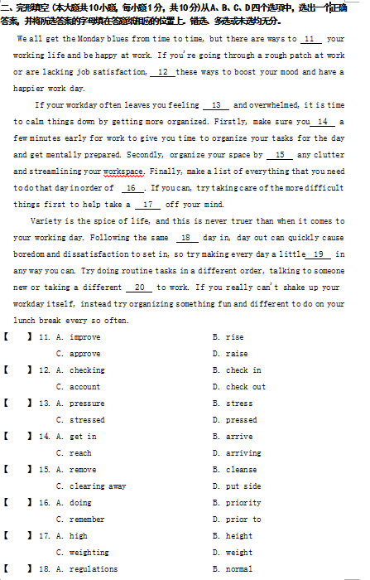

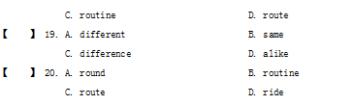

参考答案：

11. A 12. D 13. C 14. B 15. C 16. B 17. D 18. C 19. A 20. C

42.

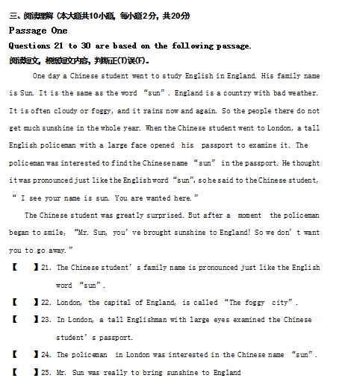

参考答案：

21. F 22. T 23. F 24. T 25. F

* 43、

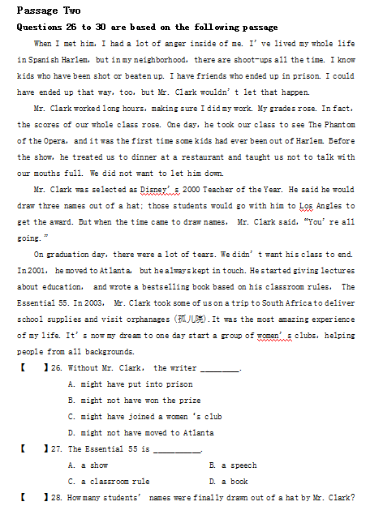

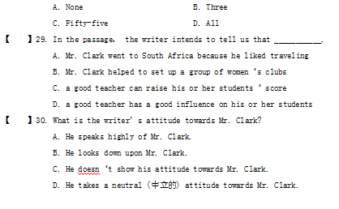

参考答案：

26. A         27. D         28. A         29. D         30. A

* 44、

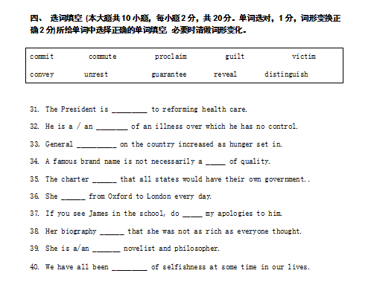

参考答案：

31. committed 32. victim 33. unrest 34. guarantee 35. partly

36. commutes 37. convey 38. revealed 39. distinguished 40. guilty

• 45、

Translation from English into Chinese

Critical reading applies to non-fiction writing in which the author puts forth

a position or seeks to make a statement.Critical reading is active reading. It involves more than just understanding what an author is saying. Critical reading involves questioning and evaluating what the author is saying, and forming your own opinions about what the author is saying.

参考答案：

批判性阅读适合于那种作者提出一个观点或试图陈述一个说法的非虚构类写作。批判性阅读是积

极阅读。它不仅仅包括理解作者说了些什么，还包括质疑和评价作者的话，并对此形成自己的观点。

• 46、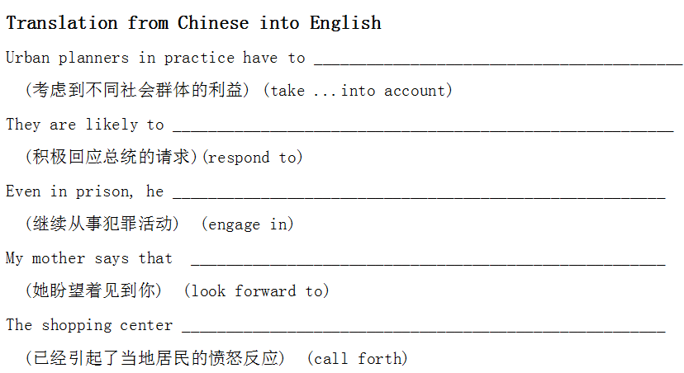

参考答案：

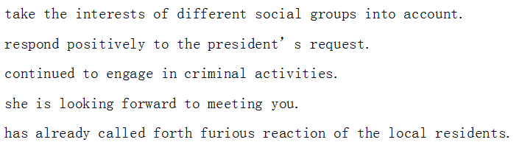

47、

In the daily drama and comedy of our life, it's nice to have friends. 11 family is extremely important, friends are a different support system of your choosing. As the saying goes, you can't choose your family, but you can choose your friends." Choosing them 12 can make your life more exciting and inspiring.

Deciding whom you choose as your friends says as much about you as it does them.You may choose your friends based 13 similar interests. You may choose them because you're both polar 14 of each other and find this interesting and intriguing. Often, friends become "friends" because they naturally gravitate（被吸引） towards each other because of similar 15 and temperaments. Sometimes it's just circumstances 16 bring two individuals together who then become friends.

17 prompts a friendship, developing one is a very rewarding experience. This is especially true when, before you know it, a certain friendship turns into a 18 lifelong close friendship. Again, it's been said that a person normally has only 19 very close friends in their life. Think of whom you deem as truly close friends. These are those select individuals you can confide in（信赖，吐露秘密） and 20 deep thoughts and concerns with, without any reservations.

【 】 11. A. However B. Moreover

C. While D. Whenever

【 】 12. A. clever B. wisely

C. intelligence D. smart

【 】 13. A. on B. before

C. after D. outside

【 】 14. A. agreed B. opposites

C. disagree D. on the contrary to

【 】 15. A. personalities B. character

C. qualities D. expressions

【 】 16. A. when B. that

C. where D. what

【 】 17. A. No matter how B. Wherever

C. Whenever D. Whatever

【 】 18. A. only B. the only

C. unique D. united

【 】 19. A. many a B. much

C. plenty of D. a couple of

【 】 20. A. hope B. have

C. share D. possess

参考答案：

11. C 12. B 13. A 14. B 15. A 16. B 17. D 18. C 19. D 20. C

48、

A Tribute to the Dog

The best friend a man has in this world may turn against him and become his enemy.His son or daughter whom he has reared with loving care may prove ungrateful. Those who are nearest and dearest to us, those whom we trust with our happiness and our good name,may become traitors to their faith.

The money that a man has he may lose. It flies away from him, perhaps when he needs it most.A man's reputation may be sacrificed in a moment of ill-considered action.The people who are prone to fall on their knees to do us honor when success is with us may be the first to throw the stone of malice when failure settles its cloud upon our heads. The one absolute, unselfish friend a man may have in this selfish world, the one that never deserts him, the one that never proves ungrateful or treacherous, is his dog.

A man's dog stands by him in prosperity and in poverty, in health and in sickness.He will sleep on the cold ground when the wintry winds blow and the snow drives fiercely, if only he can be near his master's side. He will kiss the hand that has no food to offer. He will lick the sores and wounds that come in the encounter with the roughness of the world. He guards the sleep of his pauper master as if he were a prince.

When all other friends desert, he remains.When riches take wings and reputation falls to pieces, he is as constant in his love as the sun in its journey through the heavens.If fortune drives the master forth, an outcast in the world, friendless and homeless, the faithful dog asks no higher privilege than that of accompanying him to guard him against danger, to fight against his enemies.And when the last scene of all comes and death takes its master in its embrace and the body is laid away in the cold ground, no matter if all other friends pursue their way, there by his graveside will the noble dog be found, his head between his paws, his eyes sad but open in alert watchfulness faithful and true even to death.

【 】21.The best friend a man has may be disloyal to him.

A. True B. False C. Not given

【 】22.The money a man has may fly away when he needs it.

A. True B. False C. Not given

【 】23.When severe winter sets in, the dog won’t stand by its owner.

A. True B. False C. Not given

【 】24.A pet owner must be nice to his pet, hoping that the pet keeps his company forever.

A. True B. False C. Not given

【 】25.A dog will retreat when it encounters tough difficulties.

A. True B. False C. Not given

参考答案：21. A 22.A 23. B 24. C 25. B

49、A Shoe Pattern

Harry is eighteen now. He studies in a middle school. His parents like him very much and hope he can become a famous man. So they often tell him to study hard and they do all for him. They call him at six in the morning, after breakfast his father takes him to school in a car and in the afternoon, as soon as the young man comes back, the supper is ready. Of course, he never washes his clothes or goes to buy something in the shops.

Once Harry’s father was sent to London on business. He would stay there for half a year. Leaving, he told his wife to take good care of their son. The woman had to get up earlier and did all what her husband did before. And two months later she was so tired that she was ill in bed. Now the young man got into trouble. He couldn’t do any housework. He had to do as his mother told him. Even he didn’t know where to get on the bus!

Yesterday Harry’s mother found his shoes were worn out and told him to buy a new pair in the shop. But he didn’t know how to choose. The woman had a sigh(叹息) and gave him a shoe pattern(鞋样) and told him to buy a pair of shoes himself. It’s Saturday today and Harry doesn’t go to school. With a policeman’s help, he found a shop. The shopkeeper was friendly to him. The man brought a lot of shoes and asked him to choose. When he was trying on a pair, suddenly he remembered something and took them off. The man was surprised and asked, “What’s the matter, young man?”

“I’m sorry, I’ve left the shoe pattern at home!”

【 】26. _______ always does some housework in the morning.

A. Harry’s parents B. Harry’s mother

C. Harry D. Nobody

【 】27. Harry’s parents do all instead of him because _______.

A. he’s too young

B. he has poor health

C. he’s busy with his studies

D. they hope he spends all time on studies

【 】28. The woman had to look after her son by herself because _______.

A. her husband wasn’t at home B. she was stronger than her husband

C. she knew the young man well D. she was freer than her husband

【 】29. When the man was in London, _______.

A. Harry had to stay at home B. Harry didn’t find the bus stop

C. Harry fell behind in his class D. Harry wouldn’t go to school

【 】30. The woman told her son to buy a pair of shoes because _______.

A. she didn’t know what kind he needed

B. she was busy with the housework

C. something was wrong with her

D. she wanted her son to do something himself

参考答案：26. A 27. D 28. A 29. B 30. C

50、A. Translation from Chinese into English 41--45

41.What the witness said in court was not consistent with the statement he had made to the police.

(与他对警察的陈述不一致). (be consistent with)

42. Rarely have I seen such beautiful sunset .

(我从来没见过这么美丽的落日) （rarely）

43.You have to request permission if you want to take any photos.

(必须申请获准)?(request)

44. The construction of a high way will contribute to the growth of the suburbs. (将有助于郊区的发展)?(contribute to)

45. The game was canceled because of raining.

(由于下雨) (because of)

参考答案：

41. was not consistent with the statement he had made to the police

42. Rarely have I seen such beautiful sunset.

43. have to request permission.

44. will contribute to the growth of the suburbs.

45. because of raining.

三 、综合题

1、

B. Translation from English into Chinese

45. How many of us recognize true loyalty in a friend? Loyalty consists of a friend, who will stick by you, through thick and thin. A friend who is always honest with you and never betrays the friendship with lies is a loyal friend. If you have a loyal friend, you have indeed found a true virtue in that friend.

参考答案：

我们之中有多少人能在朋友中识别出真正的忠诚?忠诚包括无论何时都会支持你的朋友。一直对你坦诚、从不撒谎背叛你的朋友才是忠诚的朋友。如果你有一位忠诚的朋友，你一定在他身上发现了真正的美德。

四 、英译汉

2、

I grew up in Lakeland, Louisiana(路易斯安那州), one of 12 children. We all lived on my parents' subsistence farm. We grew cotton, sugar cane, corn, hogs, chickens and had a large garden, but it didn't?bring in much cash. So when I was 12, I got a part-time job on a dairy farm down the road, helping to milk cows. We milked 65 cows at 5 in the morning, and again at 2 in the afternoon, seven days a week.

参考答案：我在路易斯安那州的莱克兰长大，是家里12个孩子之一。我们所有人都依赖父母的农场勉强维 持生活。我们种棉花、甘蔗、玉米，养猪、养鸡，还有一个大花园，但农场没办法让我们有多少 收入，所以我在12岁时在马路旁边的一个奶牛场里找了一份兼职工作——帮忙挤牛奶。我们要 在早晨5点钟为65头奶牛挤奶，下午2点钟还要挤一次，一周工作七天。

3、

It's so easy to take good friends for granted. Like a comfortable pair of gloves, old friends wear well. But friendships that suffer from busyness and over-familiarity can't afford to be neglected too long. They need renewal. If you want and need to keep true friendship alive and well, please, consider and think over a list of the most important qualities. Probably it will help you to understand why you and your best friend haven't called up for ages, why you're getting embarrassed while being asked " Whom are you going to have fun with this weekend ? " You may neglect your intimate friends from time to time, but if you fail to cultivate these qualities — loyalty, forgiveness, honesty, and dedication — you can't expect to keep true friends.

参考答案：

4、

Imagine life as a game in which you are juggling some five balls in the air. You name them — work, family, health, friends and spirit and you are keeping all of these in the air. You will soon understand that work is a rubber ball. If you drop it, it will bounce back.But the other four balls — family, health, friends and spirit — are made of glass, and if you drop one of these, they will be irrevocably scuffed, marked, nicked, damaged or even shattered. They will never be the same. You must understand that and strive for balance in your life.

参考答案：

五 、汉译英

5、

What he said ______________________________________________________________ (与正在处理的事件无关) （be relevant to）

参考答案：was not relevant to the issue at hand

6、The government is trying to _______________________________________________ (恢复人们对国家经济的信心) （restore）

参考答案：restore people’s confidence about the nation’s economy

7、

She felt rather guilty for she ____________________________________________ (辜负了父母对她的信任) （betray）?

参考答案：betrayed her parents’ trust

8、

The movie ________________________________________________________________ (使她想起了自己艰辛的童年)? （remind of）?

参考答案：reminded her of her miserable childhood

9、

She _________________________________________________________________ (既是有天分的音乐家，同时又是位摄影师) （as well as）

参考答案：is a talented musician as well as a photographer.

10、

On several occasions ______________________________________________________ (她都谈到了这个男孩的进步) （remark）

参考答案：she remarked on the boy’s improvement

11、There was no new and _________________________________________________ (我们做了最坏的打算)? （be prepared for）

参考答案：we were prepared for the worst.

12、

It’s important to _____________________________________________________ (把现实与虚构区分开来) （distinguish）

参考答案：distinguish between reality and fiction

13、

___________________________________________________(把近期工作与先前的工作相比较) and you will see how much you have improved. (compare...with)

参考答案：

14、

He blends right into the crowd of teenagers and ____________________________（只是他的口音与众不同）.（set…apart）

参考答案：

15、

___________________________________________(你的情况有任何改变，请告知我们) when you are away from home. (inform...of)

参考答案：

16、

Even in prison, he ________________________________________________________

（继续从事犯罪活动）.（engage in）

参考答案：

17、

My mother says that _____________________________________________________.

(她盼望着见到你)（look forward to）

参考答案：

18、

________________________________________________________(一连串的意外事件）disordered the shop. (a series of)